

**PROJECT PROPOSAL**

Project Title: Telecommunication Management System

Course Title: CSE 311

Section: 02

Group: 09

Course Instructor: Intisar Tahmid Naheen (ITN)

Lab Instructor: Fahimul Hoque

Proposal Submission Date: 02-July-2022

Members:

|  |  |
| --- | --- |
| Name | ID |
| Md Arafat Akash | 1911799642 |
| Tamim Haque | 1921549042 |
| Mohammad Sadman Wasif | 2011832042 |

**Telecommunication Management System**

**Introduction:**

This age has become an age of modern technology. It has become necessary to improve telecommunication system of this earth. Data is now being considered as an asset for modern world. Without improving telecommunication system, we can’t make progress in different fields of modern technology.

We are going to develop a website which will work for telecommunication sector of our country. It will be helpful for telephone operators and customers of our country. It will store data for both customers and operators. It will play vital role in improving telecommunication sector of Bangladesh.

Operators will get benefits from this website. It will have excellent features for welfare of customers. This website will be used by both operators and customers. It will provide service to customers. It will be a blessing for telecommunication sector of our country. It will work like a customer care service in online.

**Sitemap of the Project:**

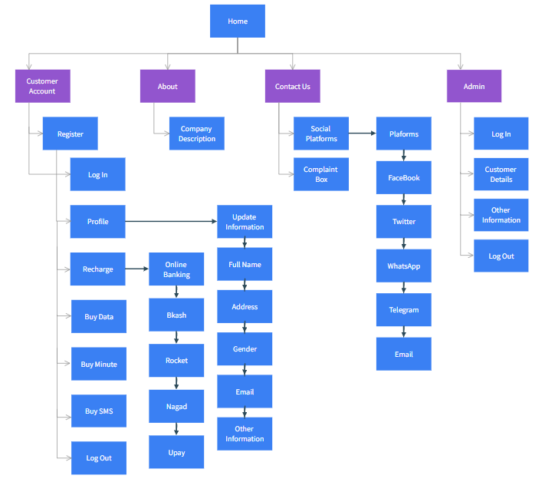

**Requirement Analysis of the Project:**

|  |  |  |  |  |  |  |  |  |  |
| --- | --- | --- | --- | --- | --- | --- | --- | --- | --- |
| **Home** | |  | | | |  | | | |
|  | | **Account Management** | | | |  | | | |
|  | |  | | | | **Register for Customers** | | | |
|  | |  | | | |  | | *Customer needs Phone Number and new password to register. Customer needs to fill the about his/her information.* | |
|  | |  | | | | **Register for Admin** | | | |
|  | |  | | | |  | | | *Admin needs email and password to register. Admin needs to fill the information about his/her position and expertise.* |
|  | | **Sign In** | | | |  | | | |
|  | |  | | | | *Whenever Customer sign in with Phone Number and password, they will be redirected to the corresponding account home page.* | | | |
|  | | **FAQ** | | | |  | | | |
|  | |  | | | | *If Customer fails to remember his/her password, he/she shall contact Admin or contact via Contact Us features.* | | | |
| **Account Home:** | | | **(Customer)** | | | | | | |
|  | | | *This page acts as a dashboard for the customer. It contains several options like- profile, recharge, buy (data, minute, sms) and account information. If a customer clicks on any of this option s/he will be redirected to that page.* | | | | | | |
|  | | | **Profile** | | | | | | |
|  | | |  | *This will contain a customer’s information. By clicking one of them, s/he will be redirected home for that class. It will have options like- full name, address, gender, email, profile picture, other information etc.* | | | | | |
|  | | |  | **Full Name** | | | | | |
|  | | |  |  | | | *It will contain Customer’s full name. s/he can also update it after thirty days.* | | |
|  | | |  | **Address** | | | | | |
|  | | |  |  | | | *It will contain Customer’s present address, permanent address.* | | |
|  | | |  | **Gender** | | | | | |
|  | | |  |  | | | *Customer has to set a gender according to themselves.* | | |
|  | | |  | **Email** | | | | | |
|  | | |  |  | | | *Customer has to provide an email address for notifications and other stuffs.* | | |
|  | | |  | **Profile Picture** | | | | | |
|  | | |  |  | | | *Customer has to set a profile picture so that s/he can be verified easily.* | | |
|  | | |  | **Other Information** | | | | | |
|  | | |  |  | | | *This will contain the other information like date of birth, blood group etc. which will be updated in future for good purpose.* | | |
|  | | | **Recharge:** | | | | | | |
|  | | |  | *Customer can recharge their account via online banking system.* | | | | | |
|  | | |  | **Online Banking:** | | | | | |
|  | | |  |  | | | *Customer can recharge their account with the help of online banking system like Bkash, Rocket, Nagad, Upay etc.* | | |
|  | | | **Buy Data** | | | | | | |
|  | | |  | *Customers can buy their data pack from this page according to their needs.* | | | | | |
|  | | | **Buy Minute:** | | | | | | |
|  | | |  | *Customer can buy their minute pack from this page according to their needs.* | | | | | |
|  | | | **Buy SMS:** | | | | | | |
|  | | |  | *Customer can buy their SMS pack from this page according to their needs.* | | | | | |
|  | | | **FAQ:** | | | | | | |
|  | | |  | *Customer can update their profile information’s. AND Customer can buy their data, minute and SMS pack from their featured pages with many types of durations like 3,7,15,30 days.* | | | | | |
|  | | |  |  | | | | | |
| **Admin:** |  | | | | | | | | |
|  | *Admin will be able to see the necessary information’s of customer. After logging in s/he will be redirected to the admin home page.* | | | | | | | | |
| **Admin home:** |  | | | | | | | | |
|  | *This is dashboard for the admin. This contains links to the several pages for various purposes Customers list, public notifications, username and password reset for customers etc.* | | | | | | | | |
|  | **Customer list:** | | | | | | | | |
|  |  | | | | *This will list all customers that registered. S/he can create, activate and deactivate any user.* | | | | |
|  | **Public Notification:** | | | | | | | | |
|  |  | | | | *S/he can send notification to any customer or every customer.* | | | | |
|  | **Username-password-reset:** | | | | | | | | |
|  |  | | | | *If any customer faces issues like “username forgot” or “password forgot”, s/he can request admin for reset that.* | | | | |
|  | **Admin Info** | | | | | | | | |
|  |  | | | | *This will contain sensitive information about admin like password, first email, second email and contact info etc.* | | | | |
|  | **Admin password reset:** | | | | | | | | |
|  |  | | | | *If admin forgets his password, he will be redirected to here. S/he will be needed all the info except the password to reset the password.* | | | | |

**Gantt Chart:**

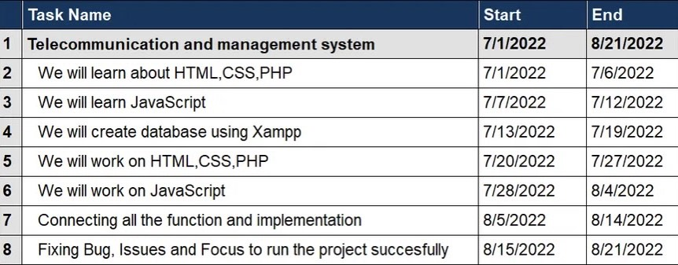

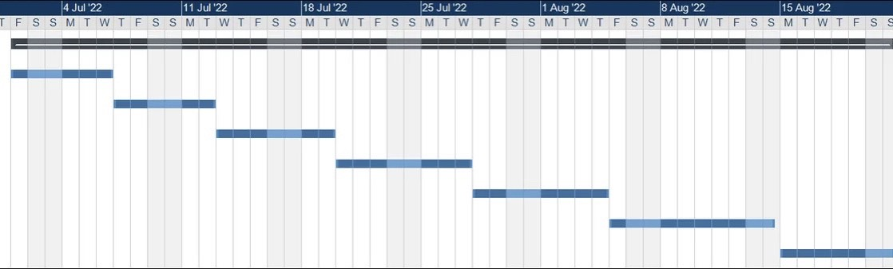

**GitHub-Link:**

https://github.com/TamimHq/CSE-311-GROUP-9